****Geethanjali College of Pharmacy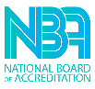

Approved by AICTE, PCI New Delhi, Permanently Affiliated to JNTUH & B. Pharmacy Accredited by NBA

Recognized Under UGC Section 2F &amp; 12B of UGC Act, 1956, by DSIR-SIRO &amp; HI/BI of MSME,

Certified by ISO 9001:2015, Cheeryal (V), Keesara (M), Medchal-Malkajgiri Dist., Telangana State- 501301.



**Activity Name:  “World Patient safety Day - Manage through IIC”**

**Mode of Activity:**  Off line

**Date:** 18-09-2023.

**Report on “World Patient safety Day - Manage through IIC”**

**Aim and Objective:**

The activity aims to organize World Patient Safety Day - Manage through IIC was held at Geethanjali College of Pharmacy on 18-8-2024. The theme for this year’s World Patient Safety Day’s is focused on**improving diagnosis for patient safety.**  The conclave was handled by Principal Dr.M.Ravikumar elucidate about **improving diagnosis for patient safety.** The first step toward effective treatment and preventative measures is a prompt and accurate diagnosis. Final diagnosis and treatment plan; follow-up and reevaluation; diagnostic testing, discussion, and findings communication; cooperation and coordination. Errors can happen at any time, which improves patient safety and lowers patient injury. Both students and teaching staff took part in and made use of the session

1. The session was conducted for all the students, teaching staff and supporting staff.
2. More than 42 members Participated and utilized this opportunity.

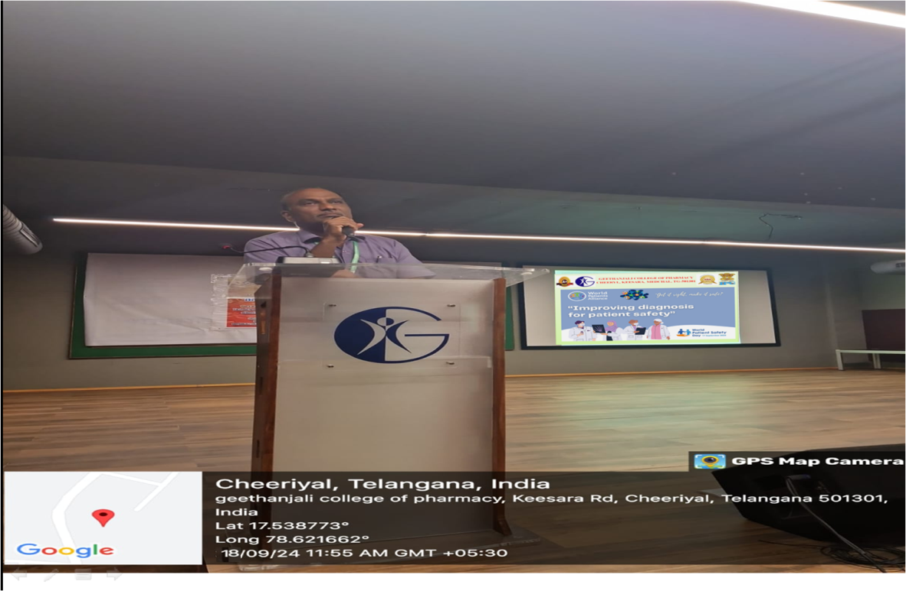

**PRINCIPAL**

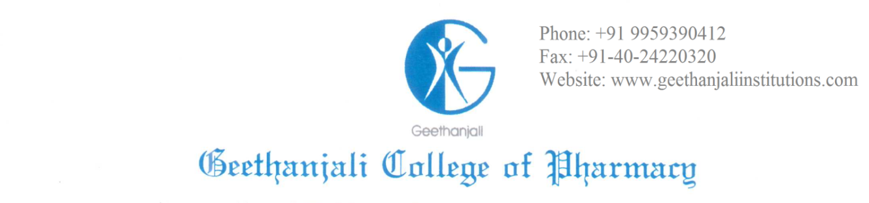

Approved by AICTE, PCI New Delhi, Permanently Affiliated to JNTUH & B. Pharmacy

Accredited by NAAC A+B. Pharmacy by NBA

Recognized Under UGC Section 2F & 12B of UGC Act, 1956, by DSIR-SIRO & HI/BI of MSME,

Certified by ISO 9001:2015

Cheeryal (V), Keesara (M), Medchal-MalkajgiriDist, Telangana State- 501301.

Date: 13/09/2024

**CIRCULAR**

Geethanjali College of pharmacy is going to organize “**World Patient safety Day”**  in our college premises at on 18th September 2024 at 11.00 am. Hence all the faculty and students are cordially invited to attend and make this event a grand success

**PRINCIPAL**